 

Q1:

Software Requirements Specification

for

Web-based Pet Medical Appointment System

**Version 1.0 approved**

**Prepared by**

**Nguyen Van A, HExxxxxx**

**FPT University Campus Hoalac**

**Tuesday, March – 26- 2024**

Q2:

<Student must replace this line, answer Q2 by drawing 1 context diagram that reflect this exam paper and copy and then paste the image of that context diagram here

Notes:

1. Draw the correct syntax to describe the context diagram (0.3 point)
2. List the name of >= 4 external entities (0.6 point)
3. Draw the data flows described in this exam paper (1.6 points)

>

2.

Customer: Represents individuals who interact with the Pet Medical Appointment System to schedule appointments for their pets, view services, and provide feedback.

Veterinarian: External entity representing licensed professionals who register their work schedules and interact with the system to manage their availability.

Google Account: Represents the external entity providing authentication services for users who opt to log in using their Google accounts.

Online Payment System: External entity responsible for handling the online payment process for appointments made by customers.

1. Data Flow

Customer -> Pet Medical Appointment System: Data flow representing customer interactions with the system, such as making appointments, viewing services, and providing feedback.

Clinic Staff -> Pet Medical Appointment System: Data flow illustrating interactions of clinic staff with the system, including managing appointments, assigning veterinarians, and sending confirmation messages.

Veterinarian -> Pet Medical Appointment System: Data flow indicating interactions of veterinarians with the system, such as registering work schedules and requesting schedule cancellations.

Google Account -> Pet Medical Appointment System: Data flow representing authentication services provided by Google for users logging in using their Google accounts.

Online Payment System -> Pet Medical Appointment System: Data flow depicting the interaction between the online payment system and the appointment system for processing payments made by customers.

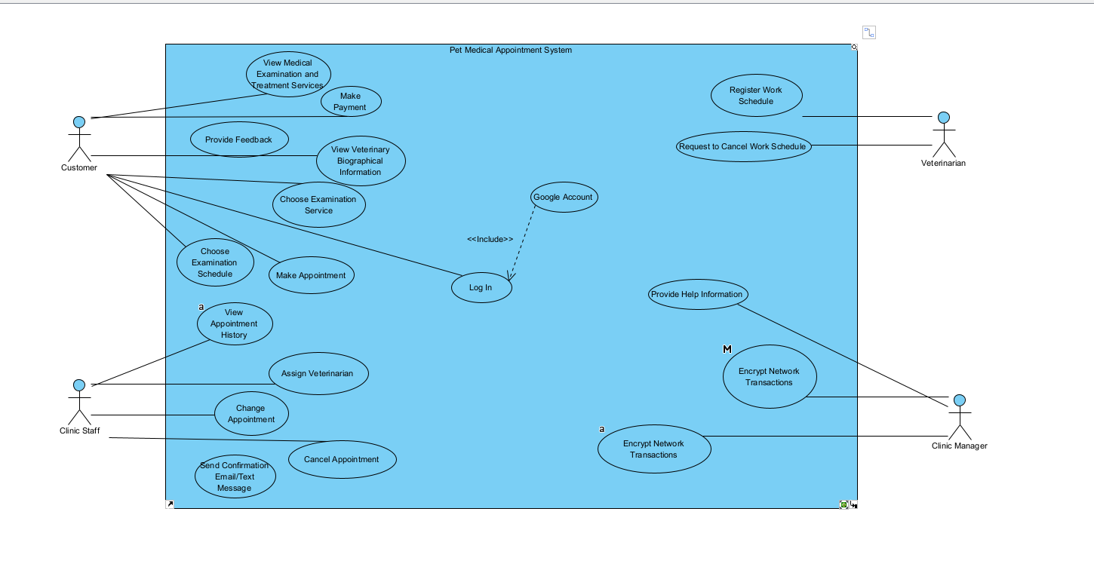

Q3:

< Student must replace this line

Notes:

1. Draw the correct syntax to describe the use case diagram (0.4 point)
2. List the name of >= 4 actors and brief descriptions (0.8 point)
3. Draw use cases and brief descriptions (2.8 points)

>

<Student must replace this line, answer Q3 by drawing 1 use case diagram that reflect this exam paper and copy and then paste the image of that use case diagram here>

< Student must replace this line, **briefly describe** the actors of the diagram by fill the content to below table>

|  |  |  |
| --- | --- | --- |
| **#** | **Actor** | **Description** |
| 01 | Customer | Represents individuals who own pets and use the Pet Medical Appointment System to schedule medical examinations and treatments for their pets. |
| 02 | Clinic Staff | Refers to the employees working at the pet clinic who manage appointments, assign veterinarians, handle cancellations or changes in appointments, and send confirmation messages to customers. |
| 03 | Veterinarian | Represents the licensed professionals responsible for examining and treating pets at the clinic. They register their work schedules, request schedule cancellations, and await approval from the clinic manager. |

< Student must replace this line, **briefly describe** the use cases of the diagram by fill the content to below table>

|  |  |  |  |
| --- | --- | --- | --- |
| **#** | **Use Case** | **Actors** | **Description** |
| UC-01 | View Medical Examination and Treatment Services | Customer | This use case allows the customer to browse and view details of medical examination and treatment services offered by the pet clinic. |
| UC-02 | Make Appointment | Customer, Clinic Staff | This use case enables the customer to schedule an appointment for their pet. The customer selects the desired examination service from the available options and chooses a suitable time slot for the appointment. |
| UC-03 | Cancel Appointment | Clinic Staff | This use case allows the customer to cancel a previously scheduled appointment. The customer can initiate the cancellation process, and if it's within the specified time frame |

Q4:

< Student must replace this line, answer of Q4 by fill the content to below table that reflect this exam paper

Notes:

1. Describe >= 5 business rules (1.5 point)
2. For each incorrect business rule, 0.3 points will be deducted

>

|  |  |  |
| --- | --- | --- |
| **ID** | **Rule Definition** | **Use cases** |
| BR-01 | Appointment Scheduling Rules | UC-02 |
| BR-02 | Cancellation Rules | UC-03 |
| BR-03 | Payment and Discount Rules | UC-02 |

**Q5:**

< Student must replace this line, the answer of Q5 must have detail and specific in number of 2 non-functional requirements for the system>

Performance Requirement:

The system must be capable of handling a minimum of 100 concurrent user sessions without experiencing any degradation in response time or system performance.

The average response time for any user action, such as viewing services, making appointments, or canceling appointments, should be less than 2 seconds under normal load conditions.

Security Requirement:

All user data, including personal information, appointment details, and financial transactions, must be stored securely and encrypted using industry-standard encryption algorithms

The system must enforce strong password policies for user accounts, requiring a minimum password length of 8 characters, including a combination of uppercase and lowercase letters, numbers, and special characters. Additionally, the system should implement mechanisms to prevent brute-force attacks and unauthorized access attempts.